Ragged Wood Art Review – guest artists creating works on wood; engraving, painting, carving

This fall, Coastal Mountains land Trust is staging a variety concert at the Camden Opera House that will involve history, paintings, stories, poetry, song and dance celebrating Ragged Mountain, in particular, and our coastal mountains in general. We want to engage artists to share their perspective on what is so special about Ragged Mountain, trails, our community….will you join us?
This is your invitation to take part in a unique art show by creating a piece of art using a slab of wood. Please come along to our office at 101 Mt. Battie Street in Camden on June 29 from 5:30 pm for a glass of wine and an explanation about the show – you’ll be able to pick out your wood ‘canvas’ at that time.
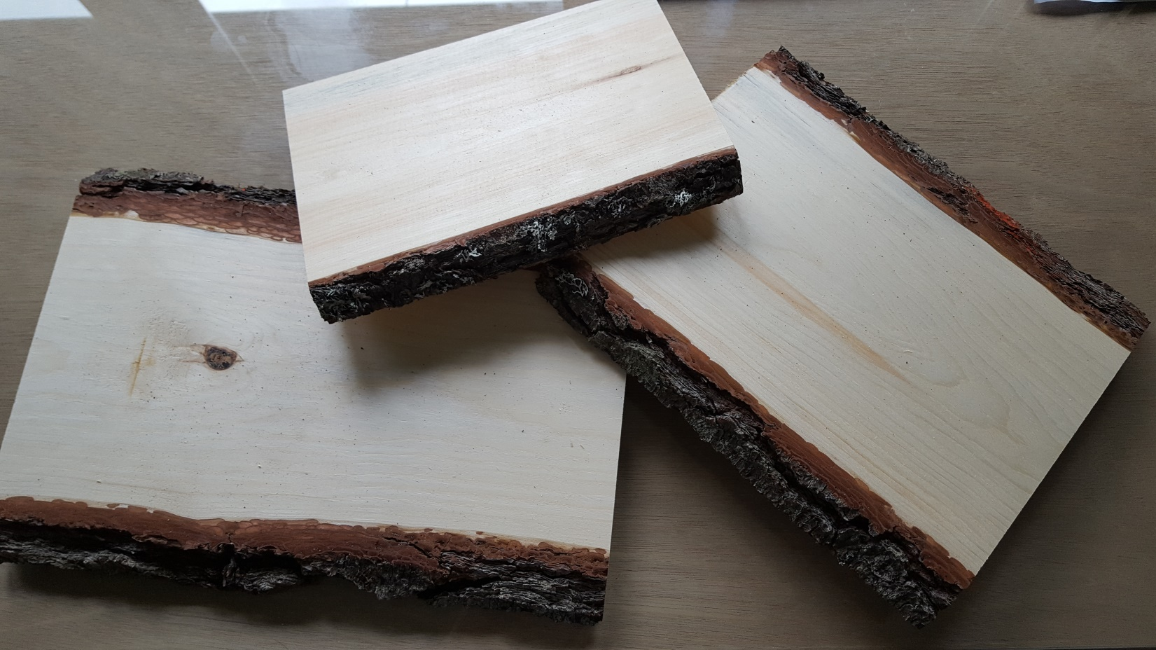There are different sizes of wood and each one is unique – made more so by your personal style and creativity. Hanging together, they will be a mesmerizing interpretation of wood, art and imagination. I really hope that you will be able to participate. If you want to be part of this but are not available on the 29th, feel free to come by Monday-Friday between 9:00 – 5:00 pm to select your piece of wood. We hope to present a wall of wood art created by local artists! These will be for sale to the public at a set price, most likely $50 each.
You will have the summer to be as creative as you like with your wood piece and then we will sell them at our showcase event on September 22. I hope to have them returned by September 1 so that we can put them on display around Camden and Rockland.
It would be wonderful if we had 100 pieces to display and sold out! I know I will buy one – I love the idea of artists using different types of ‘canvas’ to present their unique style. You will be able to select from a broad range of sizes and types of wood – round ‘cookies’ and squares.
If you know of other artists who may want to join us, please bring them along – the more the merrier!
This is also the public launch of our campaign to protect 1,400 acres of land on Ragged Mountain. This $4.2m campaign has a first deadline of December 31 to raise $1.8m. At that point, Maine Water Company will release a $200,000 gift for us to begin construction of miles two through seven of a nine mile Round the Mountain Trail circumnavigating Ragged Mountain. This exciting addition to year-round recreation in Camden and Rockport is part of why we believe our community will generously join us throughout this multi-year campaign.
You can learn more about the campaign at our website: coastalmountains.org. There is a short video done by Compass Light Productions that tells the story beautifully.
Thanks for your consideration!

